Packet Sniffing
So far we have very much looked at the issues of security from the point of view of one application talking to another without considering the nature of the way data is transmitted over the network.
In the first lecture we looked at a few things that relate to these issues.
We introduced the client server model to see how the client and server communicate with each other…

 |  |  | 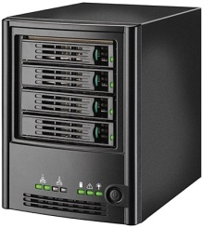 | C# middle layer
(Client side) | Embedded code included with incoming page |  |  | 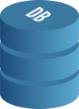
You | Browser | Network for data transfer | Web Server  (Server side) | Data layer

We have also touched on the idea that the internet is a huge collection of networks talking to each other and in reality it allows one program on one machine to communicate directly with another program on a second machine via a combination of the IP address and the port number.

Ports on a given computer may be specified to allow communications between multiple programs on the same computer e.g.
- 80 HTTP (web pages)
- 21 FTP (File transfers)
- 119 NNTP (Network News Transfer Protocol)
- 443 HTTPS (secure web pages)

Clearly all of the above points hold true and are important but there is another level of detail in TCP/IP that opens up another world of potential issues when it comes to security.

The Network Connections
Assuming you are sitting at home doing something on the internet your local computer will almost certainly make the connection to the internet via your home router. This could be a wireless (wifi) connection or a wired connection.
From here your home network connects to a Wide Area Network (WAN) typically run by your Internet Service Provider (ISP). This may involve a WAN for the area in which you live, which then links to a larger WAN for the whole city. At this point your data is now on the wider internet using high bandwidth routers and high speed connections.
To give you some idea of the number of computers that might be involved in communicating data from source to destination it is possible to use the “trace route” command. The output of this command traces the route of data from your client machine to the server and lists the IP addresses of the machines in between.
This is all well and good, however the question then arises how does the client machine’s data actually get from the client to the server and back again?

Layered Network Architectures
One way of describing a computer network is to look at it as a series of layers.
One famous layered model is called the ISO OSI seven layer model (you may have come across this already.)
ISO OSI Reference Model

“Applications”
⇓ | Application  Layer | ⇑ | Provides communication services to applications. E.g. file transfers and electronic messaging.
⇓ | Presentation  Layer | ⇑ | Encoding decoding of character (ASCII EBCDIC) sets & selecting rules to be used. Compression & security (cryptography).
⇓ | Session  Layer | ⇑ | Determines which PC talks to which PC. May manage accounting.
⇓ | Transport  Layer | ⇑ | Establishes connections of right type and quality. Initiating data transfer. Managing data to be sent. Releasing the connection.
(The three layers below make up the “sub net” they worry about how data gets from A to B. The layers above are concerned with the meaning of the data rather than its movement.)
⇓ | Network  Layer | ⇑ | Concerned with routing data between addresses. Manages the sub-net, e.g. dealing with bottlenecks or formatting issues over different types of network.
⇓ | Data Link  Layer | ⇑ | Hides the layers above from the Physical Layer. Concerned with error detection / correction. Sees data as “frames”.
⇓ | Physical  Layer | ⇑ | Delivers data from one computer to another. Concerned with placing electrical signals on wires. Sees all data as bits.
“Cabling” |  |  | The physical media data is transmitted upon. E.g. coaxial UTP fibre optic etc.

By splitting the different roles of a network into different layers it is possible to concentrate on different aspects without having to worry about the functioning of other parts.
For example, the physical layer is solely concerned with how the data is represented on the cable as electrical signals. It doesn’t care what those signals mean, nor what happens if something goes wrong with the transmission.
The data link layer is concerned with making sure that if something does go wrong there are error correction mechanisms in place to ensure that a noise error prone channel is 100% error free. It doesn’t care how the data is being represented on the cable, only that the data gets there safely.
There is a sense in which the 7 layer model is aspirational in that it typically isn’t followed 100% of the time. In some implementations the upper most layers may not be implemented at all.

TCP/IP
Another layered network architecture is TCP/IP which sort of maps to the ISO OSI model

OSI Model |  | TCP/IP
Application |  | Application
Presentation |  | Application
Session |  | Application
Transport |  | Transport
Network |  | Internet
Data Link |  | Network Interface
Physical |  | Hardware

Within TCP/IP are a number of protocols that determine how data is transmitted from source to destination.

The Representation of Data on the Cable
The lowest level of data representation on a network is at the level of the “cable” (this may be wired or wireless)
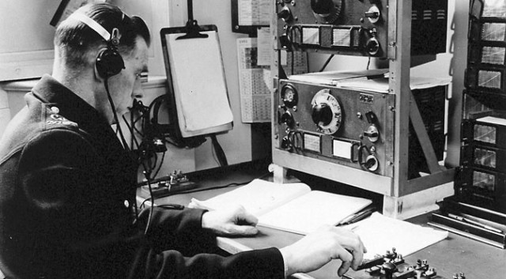

The earliest implementation of this type of system is Morse code
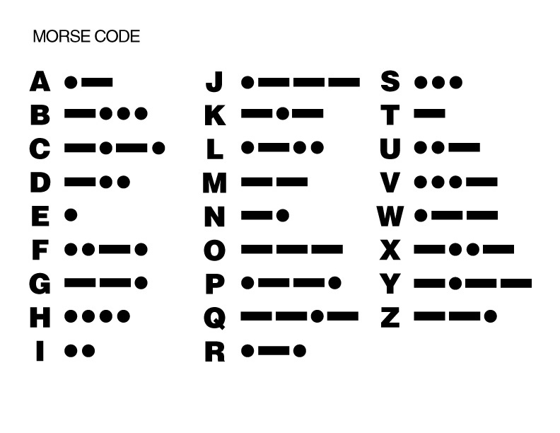
Rather than using dashes and dots to represent the data all data is broken down into binary, i.e. a series of zeros and ones.
For example the text “hello” represented in binary using UTF-8 would be “0110100001100101011011000110110001101111”
All data on the computer is encoded using zero and one.

This might then as with Morse code be represented as series of signals, e.g. a beep could be one, no beep could be zero. (It isn’t as simple as that but you get the idea!)
If you have nothing better to do you might check out the following YouTube video of a range of modem sounds.
https://www.youtube.com/watch?v=ckc6XSSh52w
If you hear the sound of an old modem it may bring back some memories but it won’t tell you much about what the data actually means so we need the upper layers to make sense of the noise and turn it into something useful.
This is rather like asking the person who receives the Morse coded message what the message says. The dots and dashes are the raw signal, the person receiving the message and writing down the words would represent an upper layer of the network architecture.
Although from the point of view of the cable the data is a series of zeros and ones from the point of view of the TCP/IP layer the data is viewed as a series of packets. Packets are the zeros and ones organised into a more logical sequence such that they make some sort of sense.

It is a bit like the Morse code operator writing down the message with the letters from the dots and dashes, but the data has yet to be given any further structure e.g. convert the letters into actual words.

TCP/IP Protocols
A protocol is an agreed upon way of doing things. We have protocols in life all the time, e.g. shaking hands with somebody when you meet them.
Breaking a protocol may result in disruption e.g. refusing to shake a person’s hand, or in the case of a computer result in disrupted data transmission.

Internet Protocol (IP)
Within TCP/IP there are a few protocols to consider starting with the Internet Protocol (IP). IP organises the raw data into frames.
IP concerns itself with getting the data to the correct machine. There isn’t a great deal of data included with IP only the destination address and some raw data (that could in fact be anything). Al it cares about is which machine the data is going to.

IP Header | Data

Since the data at this low level is only indicating which machine the data is for, it doesn’t identify which application via the port the data is going to. The data could be for a web browser on port 80 or an FTP application running on port 21.
To address this issue we need to impose more structure on the frames by bundling the data together into.

User Datagram Protocol (UDP)
A UDP packet contains additional information for routing the data.

IP Header | Port No & Checksum | Data

This time as well as the destination the packet contains the port number for the destination machine, a checksum (for error checking) and the data we want to send.
UDP is a relatively simply protocol. For example if there is an error in the checksum when the packet arrives then it is simply ignored. UDP also doesn’t communicate back to the transmitter that the data has arrived safely.
So what is the benefit of UDP?
Due to its simplicity UDP is fast protocol for transmitting data. It makes little fuss about errors and doesn’t bother reporting connection failures, but what is the point?
UDP is an ideal protocol for such things as video conferencing. For example if you have ever used say Skype and the video has gone a bit strange, this is due to UDP packets vanishing or becoming corrupt on route. Do you actually car you friends face looks a bit weird or their voice breaks up occasionally, I suspect not.

Transmission Control Protocol (TCP)
If you are talking to your friend on a Skype call would you be very upset if their voice breaks up occasionally?
What if you were making a banking transaction and half of your bank details were lost en-route? Clearly this would be a bigger problem, so there needs to be some mechanism for creating a communication channel where errors are both reported and corrected.
The packet structure of TCP is similar to that of UDP but it also includes a sequence number for each packet.

IP Header | Port No & Checksum | Sequence no | Data

By giving each packet a sequence number the receiver now knows two things:
- What order the packets are supposed to go in
- If any packets are missing when they are assembled
TCP IP uses a system of error correction called a sliding windows protocol, here are the basics of how this works.

Sliding Windows Protocol
If the transmitting computer sends a packet of data to the receiver there are a couple of questions that might be worth knowing to ensure successful communication.
Firstly is the receiver ready for more data, secondly did the data actually get through.
Transmitter
Receiver
Packet Sent
Packet Sent
Busy
To fix this we arrange for the receiver to send an acknowledgement (ACK) to indicate that it is ready for more data and that the packet arrived safely like so…
Transmitter
Receiver
Packet Sent
Packet Sent
Busy
ACK
So if the packet never arrives in the first place the ACK never gets sent back and the transmitter knows that the first packet failed to get through…
Transmitter
Receiver
Packet Sent
Packet Resent
Busy
Destroyed
Time out
This gives us some measure of simple error detection and correction. If in this case the ACK is just delayed and a duplicate copy of the first packet is sent it doesn’t matter. Since the packets are numbered and the receiver gets a second copy of packet 42 it just ignores it as a duplicate.
TCP Isn’t as fussy as this example indicates though. It is capable of having multiple packets in flight waiting for multiple ACKS using a rotating packet numbering system called a sliding window.
Transmitter
Receiver
Packet 1
ACK 1
Packet 2
Packet 3
Packet 4
Packet 5
ACK 2
ACK 3
ACK 4
ACK 5
This speeds up the whole process by sending more data at the same time.

The Problem with Packets
One of the reasons why we have looked at some of these low level processes is to get a sense of what is going on within the network.
With all of the data travelling back and forth it opens up a potential security hole in the system.

Wireshark
https://www.wireshark.org/
Wireshark is a network packet analyser and may be used to capture the packets travelling over the network typically saving them to a file called a PCAP file for further study.
A tool such as this can be used for perfectly legitimate uses such as troubleshooting network problems, or for understanding network protocols or for “other purposes.”
There are a number of ways you might gain access to the network. You might simply use a machine that is legitimately logged onto the network; you could access the wifi using a hacking tool or you may use a knife to cut a cable and add a new machine to the network which is not authorised.
Below is an example of a PCAP file, having now discussed the nature of the data floating around the network the contents of the data should start to make some sense.
For example we are able to see the ACK packets with their sequence numbers…
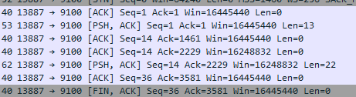
Unfortunately we are also able to see something far more interesting.
When the user of a system enters some data on a web site (say a username and password) the data is also bundled in a packet and sent over the network as plain text.
So in the example PCAP file on the web site we had Wireshark running while the user entered their username and password. As soon as they pressed submit a POST request was sent from client to server.
We can see this POST request within the data…
Using Wireshark we may also examine the data stored in the packet which looks like this…
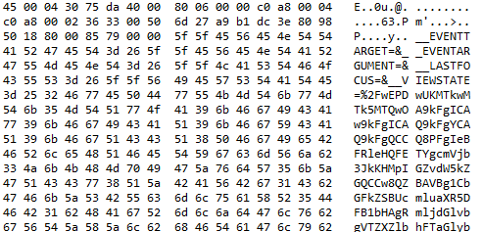
Not very exciting, but if we scroll to the end of the HTTP POST request we see the following data…
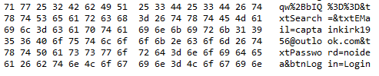
Here we can see the names of the text boxes txtEMail and txtPassword along with the data being sent in the POST i.e. the user’s email captainkirk1959@outlook.com and their password “noidea”!
Clearly this is a potential problem!

Secure Socket Layer (SSL)
SSL uses a system of public and private keys to encrypt the data.
- The browser makes a secure HTTP request HTTPS on port 443
- The server sends back a digital certificate verifying its credentials
- The client verifies the certificate with the issuing agency
- Using the public key data is encrypted between client and server

The certificate is a file verifying that the server is a trusted source. The certificates are issued by a certificate authority.
Setting up SSL on IIS is fairly simple the downside is that setting up a certificate that is approved by a certificate authority will cost money.
IIS does allow for self signed certificates to be created. These still allow for an SSL connection to be established but may generate the following error in a browser...
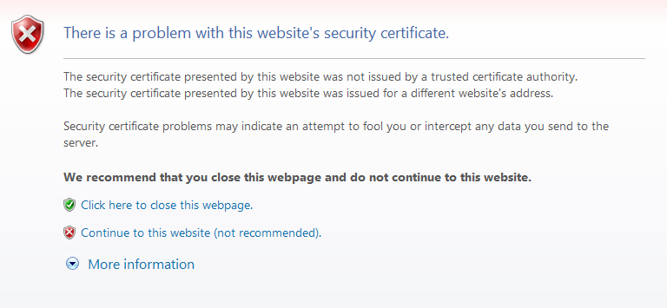

Virtual Private Networks
In a similar manner to SSL a VPN encrypts your data but creates a network within a network.
There are a number of features of a VPN that makes it more secure and private.
- It masks your IP address
- It can make it appear you are in a different country
- Packets may be encrypted
A VPN can be a very useful form of protection if you are using public wifi and your data is being passed around the public network in plain text. All communications in passwords become inaccessible to somebody wanting to examine the packets you are generating.

